1. **Architecture Overview**

This document outlines the **Architecture Design** of an AI-driven hotel reservation system, designed with a strong emphasis on the Model-View-Controller (MVC) architectural pattern. This approach ensures a scalable, maintainable, and highly personalized user experience.

**2. MVC Architecture Overview**

***The system's architecture aligns with the MVC pattern, separating the application into three main components:***

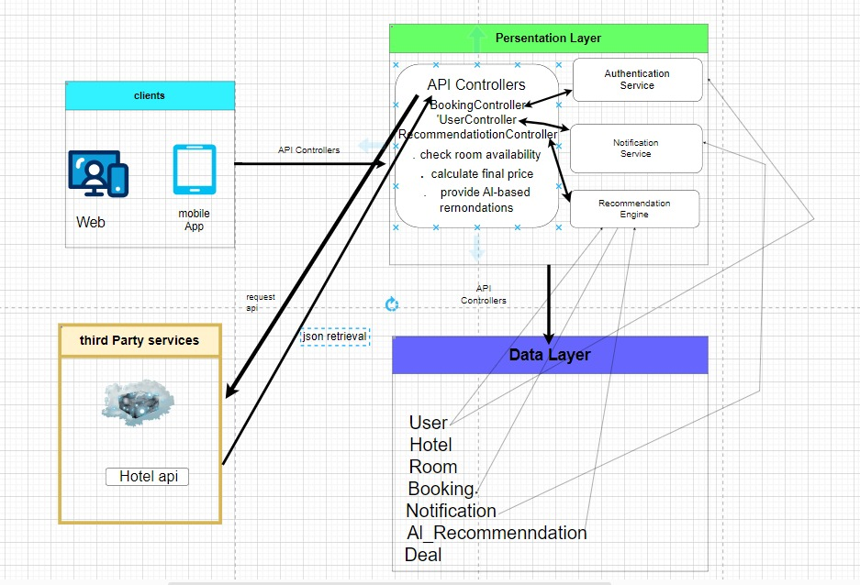

***Figure 1 Illustration of the Architecture Design:*** *System Architecture Overview, the system clearly delineates these components:*

**Presentation Layer:**

* **Controllers:** Handle user input, communicate with Models to process data, and update the Views accordingly. They act as the intermediary between the user and the system.
* **Views:** Present data and information to the user through the user interface. They display the output and send user actions back to the Controllers.

**Data Layer:**

* Responsible for data storage, retrieval, and persistence. This layer abstracts access to databases or other data sources and provides the Models with necessary data operations.
* **Models:** Manage application data, business logic, and rules. They represent the core data and behavior of the application.

**Client Layer:**

* Represents the end-user interface environment (e.g., web browser, mobile app) where users interact with the system. It communicates with the Presentation Layer to send user requests and display results.

**Outer Layer: Third-Party API Integration**

* This external layer involves third-party services or APIs. The **Controllers** in the Presentation Layer handle communication with these external APIs, managing requests, responses, and integrating third-party data or functionality into the system.

**3. Detailed Component Breakdown (MVC Context)**

* **View:** Web and mobile applications handling UI rendering, display of hotel data, and user input.
* **Controller:** API Controllers: Entry points for client requests, orchestrating operations like booking, user management, and recommendation requests by interacting with the Model.
* **Model: Data Layer and Services:**
  + Authentication Service: Manages user authentication and authorization.
  + Notification Service: Handles sending system notifications.
  + Recommendation Engine: Applies AI algorithms for personalized recommendations.
  + Third-Party Services (Amadeus API): External data sources providing hotel data.

**4. Benefits of this MVC-Aligned Architecture**

* **Separation of Concerns:** Clear responsibilities for each component.
* **Modularity and Reusability:** Loosely coupled components allow independent development and reuse.
* **Testability:** Enables isolated testing of Model, View, and Controller.
* **Scalability:** Facilitates independent scaling of components.
* **Flexibility**: Allows easy integration of new algorithms and external systems.

**5. Conclusion**

*The AI-driven hotel reservation system's architecture, built on MVC, provides a robust, adaptable, and scalable foundation. This design ensures maintainability, flexibility, and efficient handling of complex business logic and diverse data sources, leading to a highly personalized user experience.*